**Practice Assignment 1**

**Some insights on Method Overloading in Python**

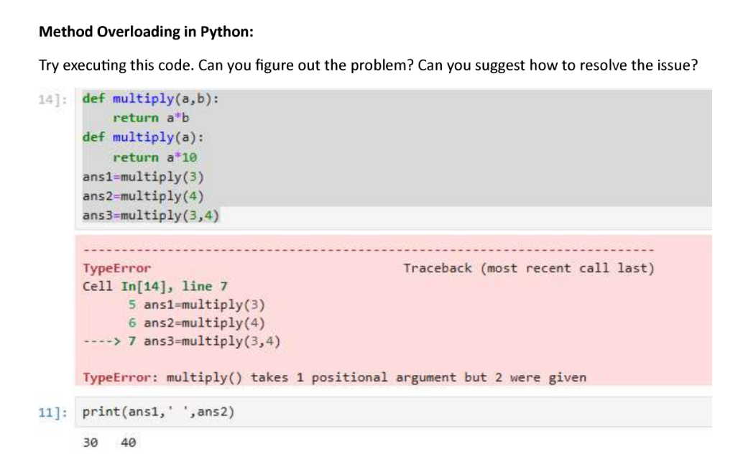**PROBLEM:**

**SOLUTION:**

**Problem Identification:**

As a python does not support true method overloading therefore, defining two or more functions with same names makes the previous ones unfunctional. As a result, two arguments giving by the user raises error.

**Problem Solution:**

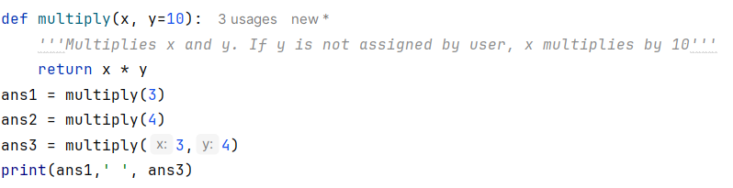**INPUT**

**OUTPUT**

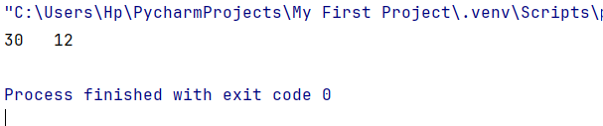

In the above code, I modified y argument by providing it with a constant value i.e. “10”. With that if y is not provided by the user, x is by itself multiplied by 10. However, providing x is necessary to execute the program.